高级英语理解
阅读三种境界：解文字、析结构、论意义

理解文字
如何理解每一个单词、词组、搭配、时态、语气、修辞？如何翻译，或者是不是根本无法完全翻译出来？为什么要有冠词，拿掉这个the行不行？英语里的A和B常译作汉语的同一个词，那将本文中的A换作B，意思有差别吗？……这些问题非常琐碎，没有累年之功，很容易陷于语言知识碎片搅拌成的字母泥沼，不可自拔。

Fun English
- Hopeless widower, Nothing can repair a broken heart.
Hopeful widow, Except by re-pairing.

- Science is always wrong.
It never solves a problem without creating ten more.
(Bernard Shaw)
- Failure is the mother of success.
- Reading is to the mind what exercise is to the body.
- An eye for an eye, a tooth for a tooth
- The restaurant becomes popular for its wide range of foods that suit all tastes and pockets.
- Virtue and vice are different: the former leads to peace, the latter to pain.

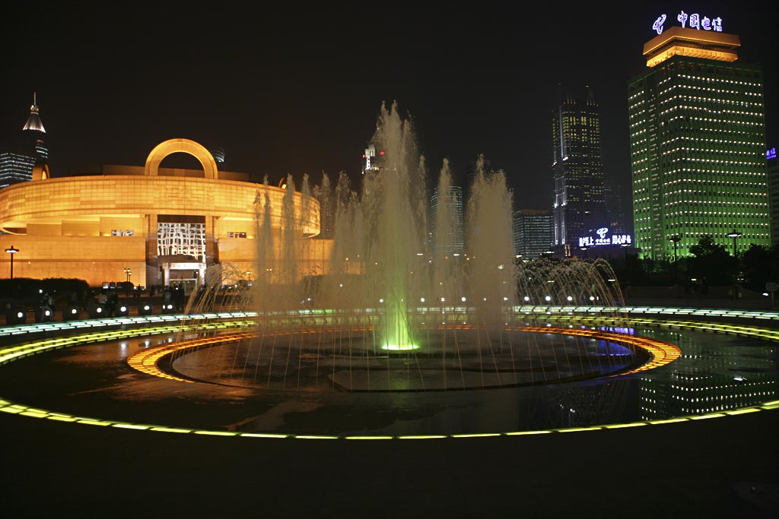

- At the center of the People’s Square is a fountain, which is used to decorate the square, honor events, and entertain city residents.

- At the center of the square stands a musical foundation that shoots out water every 15 minutes or so.

- At the center of the square stands a musical foundation that shoots out water — to the ahs and ohs of the tourists around — every 15 minutes or so.

修辞格(figures of speech)
  - 提高语言表达效果的语言艺术
  - 语言具体形象、生动活泼，美的享受

常用英语修辞格

1.生动形象的Simile(明喻)
2.含而不露的Metaphor(隐喻)
3.含蓄典雅的Metonymy(转喻)
4.蕴涵新意的Synecdoche(提喻)
5含蓄典雅的Allusion(引喻/典故)
6.无灵有灵的Personification(拟人)
7.闪烁其词的Euphemism(委婉)
8.强化语意的Hyperbole(夸张)
9.渐入佳境的Climax(渐进)
10.相映相衬的Antithesis(对照)
11.排迭匀称的Parallelism(平行)
12.发人深思的Paradox(隽语)
13.矛盾统一的Oxymoron(矛盾修饰)
14.一唱三叹的Repetition(重复)
15.音律优美的Alliteration(头韵)
16.一语两意的Pun(双关)
17.冷嘲热讽的Irony(反语)
18. 言简意赅的Ellipsis(省略)

常用英语修辞格的实例
18届五中全会
China's new five-year plan covers home stretch to a moderately prosperous society.
我国新的五年计划规划了建成小康社会的"最后一公里"。

万圣节网络用语
You get home, tired after a long day's work and ready for a relaxing night alone. You reach for the light switch, but another hand is already there.
你工作一天回到家，一身疲惫，准备独自享受放松的夜晚。你伸手去开灯，却摸到开关上有另一只手在那儿。

Don't be scared of the monsters, just look for them. Look to your left, to your right, under your bed, behind your dresser, in your closet but never look up, she hates being seen.
别害怕那些鬼鬼怪怪，找到他们。看看左边，看看右边，看看床下、衣橱后面、柜子里面，但是千万别抬头。她讨厌被人看见。

10月21日晚习近平主席伦敦市政厅举行招待晚宴，并发表了重要演讲

再次来到英国，看到耸立的大本钟，看到潋滟的泰晤士河，我有一种“不知何处是他乡”的感觉。
Coming back here and seeing the towering Big Ben and rippling River Thames, I feel very much at home.

“生存还是毁灭，这是一个问题。”哈姆雷特的这句话，给我留下了极为深刻的印象。
“To be or not to be, that is the question.” This line from Hamlet has left a lasting impression on me.

前不久，Facebook创始人、CEO兼中文爱好者马克·扎克伯格（Mark Zuckerberg）在清华经管学院发表了一段长达20多分钟的全中文脱稿演讲，用三个故事分享了自己创业的心路历程，网友惊叹连连。

►那时候，互联网上有很多网站，你差不多可以找到所有的东西。可是没有服务帮我们找到生活中最重要的东西：人。
At the time, I used the Internet and there were products to find almost anything I wanted. But there was no service to look up the thing that matters most to us - people.

►马云说过一句话我很喜欢：“和15年前比， 我们很大；但和15年后比，我们还是个婴儿。”
Jack Ma has a great quote I often use: "Compared to 15 years ago we're big. Compared to 15 years from now, we're still a baby."

习近平9月3日 阅兵讲话

战争是一面镜子，能够让人更好认识和平的珍贵。今天，和平与发展已经成为时代主题，但世界仍很不太平，战争的达摩克利斯之剑依然悬在人类头上。我们要以史为鉴，坚定维护和平的决心。
War is like a mirror. Looking at it helps us better appreciate the value of peace. Today, peace and development have become the prevailing trend, but the world is far from tranquil. War is the sword of Damocles that still hangs over mankind. We must learn the lessons of history and dedicate ourselves to peace.

让我们共同铭记历史所启示的伟大真理：正义必胜！和平必胜！人民必胜！
Let us bear in mind the great truth of history: Justice will prevail! Peace will prevail! The people will prevail!

全面二孩政策universal two-child policy
China further relaxed its more than three-decade-old family planning policy, according to a statement issued on Thursday by the Communist Party of China Central Committee. The statement said the country's aging trend would be actively addressed by the universal two-child policy.
29日，中共中央委员会发布公报称，中国将进一步放开实施了30多年的计划生育政策。公报指出，"全面二孩政策"将有效应对人口老龄化趋势。

修辞格的定义
- 转喻(metonymy)
亦称借喻，是通过相近的联想，借喻体代替本体。它根本不说出本体事物，直接用比喻事物代替本体事物，用某一事物的名称代替另一个与它关系密切的事物名称，只要一提到其中一种事物，就会使人联想到另一种。

- 提喻(synecdoche)
是指用部分代表整体，或用整体代表部分的修辞方法。

- 提喻(synecdoche)
是指用部分代表整体，或用整体代表部分的修辞方法。

- 隽语(paradox)
是一种字面矛盾反常而道理深刻、意味隽永的特殊警句。

- 渐进(climax)
是使语义的层次递增的修辞方法，也就是说，为了突出重点，加强语义，采用从轻到重、由浅入深、从低到高、循序渐进的原则来安排句子。

